1. The height of an object launched vertically is given by  where:

**NO *GRAPHING*** CALCULATOR **NO *GRAPHING*** CALCULATOR **NO *GRAPHING*** CALCULATOR

$v_{0}$ = initial velocity $h_{0}$ = initial height

You launch a model rocket from a 10 foot high platform with an initial velocity 128 ft/sec.

**WORK SPACE**

1. Write an equation that models the height of the rocket at time *t*.
2. Find the height of the rocket after 3 seconds.
3. At what time(s) is the rocket at a height of 202 ft?
4. When does the rocket reach the maximum height? What is the maximum height?

1. 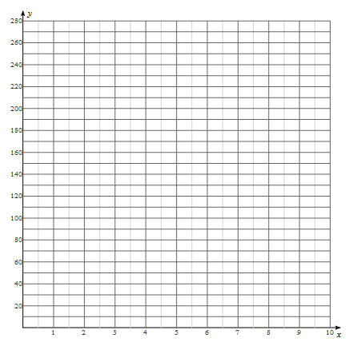When does the rocket land on the ground?
2. Using the information you have collected above, sketch a graph depicting the rockets height at time t.

*height (feet)*

1. The equation you wrote above only models the height of the rocket while it is in the air. Find the domain and range of this function.

*time (seconds)*

1. ****For each quadratic equation, find the discriminant. State the number and type of solutions. Using this information, match the quadratic equation to one of the graphs below.   
     
   i.) ii.) iii.)

**NO *GRAPHING*** CALCULATOR **NO *GRAPHING*** CALCULATOR **NO *GRAPHING*** CALCULATOR

* 1. y = 2x2 + 6x + 2

**WORK SPACE**

Discriminant:  
   
 Number of Solutions:  
  
 Type of Solutions: Real or Imaginary  
 *circle one*  
  
 Graph: i. ii. iii.

*circle one*

* 1. y = 2x2 + 4x + 2

Discriminant:  
   
 Number of Solutions:  
  
 Type of Solutions: Real or Imaginary  
 *circle one*  
  
 Graph: i. ii. iii.

*circle one*

* 1. y = 2x2 + 1x + 2

Discriminant:  
   
 Number of Solutions:  
  
 Type of Solutions: Real or Imaginary  
 *circle one*  
  
 Graph: i. ii. iii.

*circle one*

**NO *GRAPHING*** CALCULATOR **NO *GRAPHING*** CALCULATOR **NO *GRAPHING*** CALCULATOR

1. ****A quadratic function is given by f(x) = ax2 + bx + c. Three examples of quadratic functions are shown below.

i.) ii.) iii.)

**a.**) In which of the following functions is the constant "a" negative? Explain your reasoning.

If we were to solve the equation f(x) = 0 using the quadratic formula, answer the following questions.

**b.)** In which of the following examples would the discriminant be positive? How many solutions would this equation have? What type of numbers are these solutions?

**WORK SPACE**

**c.)** In which of the following examples would the discriminant be negative? How many solutions would this equation have? What type of numbers are these solutions?

1. In which of the following examples would the discriminant be zero? How many solutions would this equation have? What type of numbers are these solutions?
2. Given the function 
3. Identify the domain and range of *f*(*x*).

***GRAPHING*** CALCULATOR ***GRAPHING*** CALCULATOR ***GRAPHING*** CALCULATOR

1. Graph *f*(*x*)

|  |  |
| --- | --- |
| ***x*** | ***f(x)*** |
|  |  |
|  |  |
|  |  |
|  |  |
|  |  |
|  |  |
|  |  |

1. Solve the equation *f*(*x*) = *3* (show your work on the graph).
2. Given the function 
   1. Identify the domain and range of *f*(*x*).

***GRAPHING*** CALCULATOR ***GRAPHING*** CALCULATOR ***GRAPHING*** CALCULATOR





* 1. Graph *f*(*x*)

|  |  |
| --- | --- |
| ***x*** | ***f(x)*** |
|  |  |
|  |  |
|  |  |
|  |  |
|  |  |
|  |  |
|  |  |

* 1. Let.   
      Solve the equation *f*(*x*) = g(x) algebraically.

1. A polynomial function is given by f(x) = 2x3 + 11x2 + 17x + d. A second polynomial function is given by g(x) = 2x3 + 3x2 + cx + 5. A third polynomial function is given by h(x) = ax3 + 4x2 - 14x + 5.

**NO *GRAPHING*** CALCULATOR **NO *GRAPHING*** CALCULATOR **NO *GRAPHING*** CALCULATOR

**WORK SPACE**

* 1. Given that the one of the factors of f(x) is x+4, find the value of d. Explain your reasoning.
  2. Given that one of the factors of g(x) is x+1, find the value of c. Explain your reasoning.
  3. Find the remainder when the polynomial f(x) + g(x) is divided by x+2.
  4. When h(x) is divided by x+3, there is a remainder of 2. Find the value of a. Explain your reasoning.